**Agile Methodologies**

Agile methodology is an iterative and adaptive approach to project management and software development that values flexibility, collaboration, and customer satisfaction through continuous feedback and incremental delivery

**12 principles of agile manifesto**

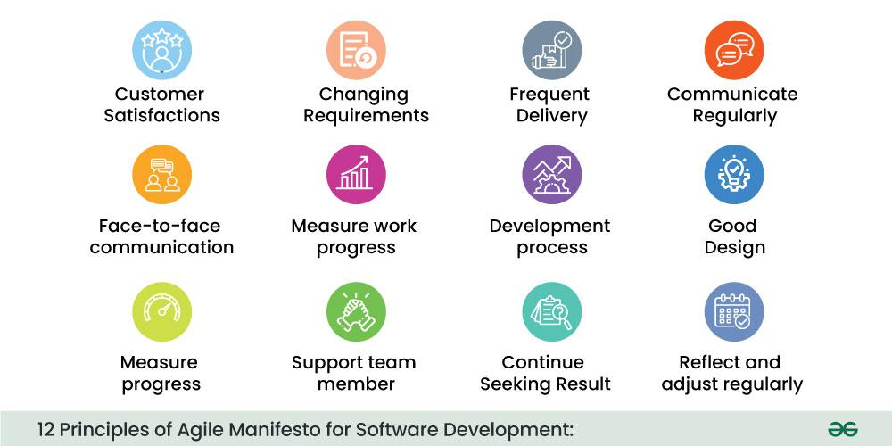

**Scrum Master**

The scrum master is what is called a specific accountability on the scrum team, along with the accountabilities of product owners and developers.

**Product Owner**

A Product Owner is a role within the Scrum framework responsible for maximizing the value of a product by managing and prioritizing its Product Backlog

**How an agile team plans their work:**

Agile teams plan iteratively and collaboratively, starting with a broad product roadmap and then focusing on smaller, time-boxed iterations called sprints. They break down work into [user stories](https://www.google.com/search?rlz=1C1GCEA_enIN1177IN1177&cs=0&sca_esv=61ade5bcf5ab3323&q=user+stories&sa=X&ved=2ahUKEwi5l9C5prmPAxWmTmwGHeZuBsgQxccNegQIAxAB&mstk=AUtExfA1vFGCCubHWr3vTmaUZdJjK7tspW2yMfAmbkA3ZKPbNLm3QurH5ZBl-OQ4BRhspLU3KvX2P-gYNNV23ubvtqTxJIWZ08vrlTf6TkMwi11PNsK6nT6pB8oXpYeOP2h2isU&csui=3), estimate them, and select a subset for each sprint in [sprint planning](https://www.google.com/search?rlz=1C1GCEA_enIN1177IN1177&cs=0&sca_esv=61ade5bcf5ab3323&q=sprint+planning&sa=X&ved=2ahUKEwi5l9C5prmPAxWmTmwGHeZuBsgQxccNegQIAxAC&mstk=AUtExfA1vFGCCubHWr3vTmaUZdJjK7tspW2yMfAmbkA3ZKPbNLm3QurH5ZBl-OQ4BRhspLU3KvX2P-gYNNV23ubvtqTxJIWZ08vrlTf6TkMwi11PNsK6nT6pB8oXpYeOP2h2isU&csui=3). Daily stand-ups ensure alignment and address blockers, while [sprint reviews](https://www.google.com/search?rlz=1C1GCEA_enIN1177IN1177&cs=0&sca_esv=61ade5bcf5ab3323&q=sprint+reviews&sa=X&ved=2ahUKEwi5l9C5prmPAxWmTmwGHeZuBsgQxccNegQIBRAB&mstk=AUtExfA1vFGCCubHWr3vTmaUZdJjK7tspW2yMfAmbkA3ZKPbNLm3QurH5ZBl-OQ4BRhspLU3KvX2P-gYNNV23ubvtqTxJIWZ08vrlTf6TkMwi11PNsK6nT6pB8oXpYeOP2h2isU&csui=3) and [retrospectives](https://www.google.com/search?rlz=1C1GCEA_enIN1177IN1177&cs=0&sca_esv=61ade5bcf5ab3323&q=retrospectives&sa=X&ved=2ahUKEwi5l9C5prmPAxWmTmwGHeZuBsgQxccNegQIBRAC&mstk=AUtExfA1vFGCCubHWr3vTmaUZdJjK7tspW2yMfAmbkA3ZKPbNLm3QurH5ZBl-OQ4BRhspLU3KvX2P-gYNNV23ubvtqTxJIWZ08vrlTf6TkMwi11PNsK6nT6pB8oXpYeOP2h2isU&csui=3) provide feedback and foster continuous improvement for future planning cycles.

Tasks should be planned according to the user requirements

**Advantages of agile methodologies**

**Scrum**

**Scrum framework**

**Uses of Scrum**

**Applications of Scrum in project management:**

Sprint planning meeting

Tracking progess

**Advantages and disadvantages of scrum**

<https://www.simplilearn.com/scrum-project-management-article>